**ASSIGNMENT 3**

|  |  |
| --- | --- |
| **TEAM ID** | PNT2022TMID38230 |
| **PROJECT NAME** | Smart Fashion Recommender Application |
| **NAME** | S Madhan |
| **ROLL NO** | 412319104014 |

**Questions:**

1. Create Usertable with user with email, username, roll number, password.

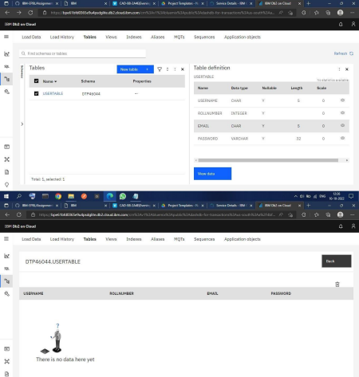

2. Perform UPDATE,DELETE Queries with user table.

**UPDATE TABLE:-**

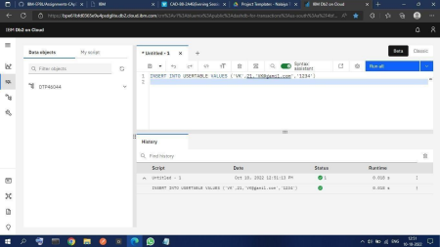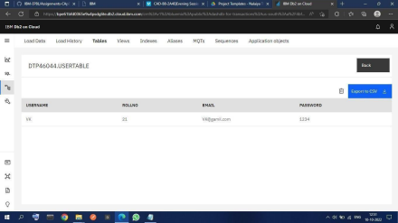

**DELETE TABLE:-**

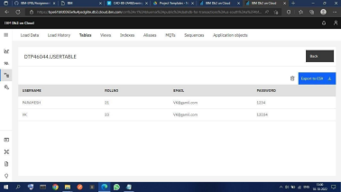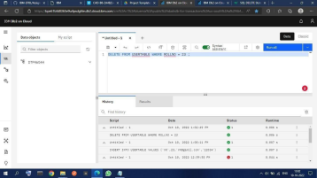

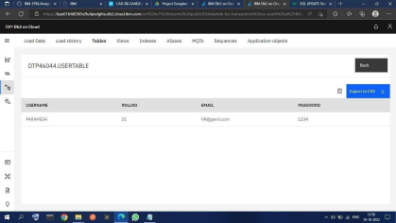

3.Connect python code to db2.

**NOTE:- Question 4 contains Question 3 answer**

4. Create a flask app with registration page, login page and welcome page. By default load the registration page once the user enters all the fields store the data in database and navigate to login page authenticate user username and password. If the user is valid show the welcome page

**Answers**

**App.py**

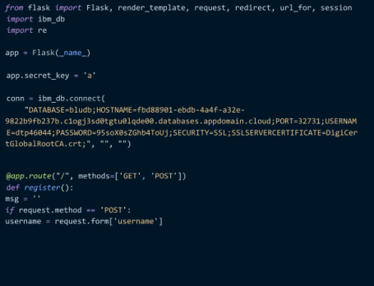

email = request.form['email']

password = request.form['password']

sql = "SELECT * FROM users WHERE username =?"

stmt = ibm_db.prepare(conn, sql)

ibm_db.bind_param(stmt, 1, username)

ibm_db.execute(stmt)

account = ibm_db.fetch_assoc(stmt)

print(account)

*if* account:

msg = 'Account already exists !'

*elif* not re.match(r'[^@]+@[^@]+\.[^@]+', email):

msg = 'Invalid email address !'

*elif* not re.match(r'[A-Za-z0-9]+', username):

msg = 'name must contain only characters and numbers !' *else*:

insert_sql = "INSERT INTO users VALUES (?, ?, ?)"

prep_stmt = ibm_db.prepare(conn, insert_sql)

ibm_db.bind_param(prep_stmt, 1, username)

ibm_db.bind_param(prep_stmt, 2, email)

ibm_db.bind_param(prep_stmt, 3, password)

ibm_db.execute(prep_stmt)

msg = 'You have successfully registered !'

*elif* request.method == 'POST':

msg = 'Please fill out the form !'

*return* render_template('register.html', msg=msg)

@*app*.*route*('/login', methods=['GET', 'POST'])

def *login*():

*global* userid

msg = ''

*if* request.method == 'POST':

username = request.form['username']

password = request.form['password']

sql = "SELECT * FROM users WHERE username =? AND password=?" stmt = ibm_db.prepare(conn, sql)

ibm_db.bind_param(stmt, 1, username)

ibm_db.bind_param(stmt, 2, password)

ibm_db.execute(stmt)

account = ibm_db.fetch_assoc(stmt)

print(account)

*if* account:

session['loggedin'] = True

session['id'] = account['USERNAME']

userid = account['USERNAME']

session['username'] = account['USERNAME']

msg = 'Logged in successfully !'

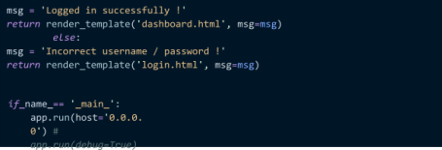

**Register.html**

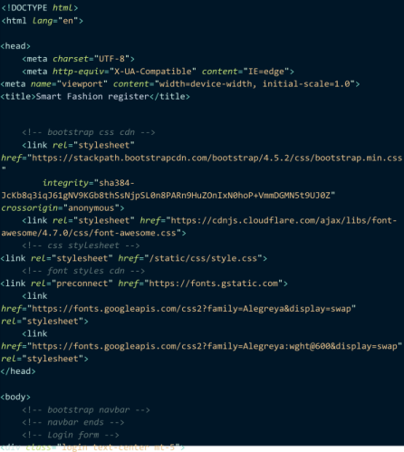

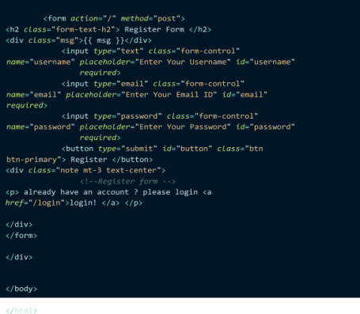

**Login.html**

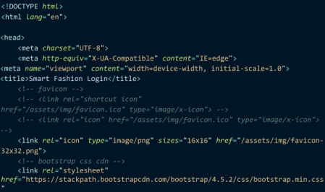

*integrity*="sha384-

JcKb8q3iqJ61gNV9KGb8thSsNjpSL0n8PARn9HuZOnIxN0hoP+VmmDGMN5t9UJ0Z" *crossorigin*="anonymous">

<link *rel*="stylesheet"

*href*="https://cdnjs.cloudflare.com/ajax/libs/font

awesome/4.7.0/css/font-awesome.css">

<!-- *css stylesheet* -->

<link *rel*="stylesheet" *href*="/static/css/style2.css">

<!-- *font styles cdn* -->

<link *rel*="preconnect" *href*="https://fonts.gstatic.com">

<link

*href*="https://fonts.googleapis.com/css2?family=Alegreya&display=swap" *rel*="stylesheet">

<link

*href*="https://fonts.googleapis.com/css2?family=Alegreya:wght@600&display=swap" *rel*="stylesheet">

</head>

<body>

<div *class*="login text-center mt-5">

<form *action*="/login" *method*="post">

<h2 *class*="form-text-h2"> Login Form </h2>

<div *class*="msg">{{ msg }}</div>

<div *class*="form-group mb-3">

<label *class*="label" *for*="username">Username</label>

<input *type*="text" *class*="form-control" *placeholder*="Username" *name*="username" *required*>

</div>

<div *class*="form-group mb-3">

<label *class*="label" *for*="password">Password</label>

<input *type*="password" *class*="form-control"

*placeholder*="Password" *name*="password" *required*>

</div>

<button *type*="submit" *id*="button"

</button>

*href*="/">register! </a> </p> </div>

</form>

</div>

</body>

</html>

*class*="btn btn-primary"> Login

<div *class*="note mt-3 text-center"> <!--*Register form* -->

<p> Don't have an account yet? Click here to <a

**Style.css**

* {

margin: 0;

padding: 0;

}

body {

background-color: aqua !important; display: flex;

flex-direction: column;

align-items: center;

justify-content:

center;

}

form {

display: flex;

flex-direction: column;

align-items: center;

justify-content:

center;

background-color:

white; width: 40%;

height: 450px;

border-radius: 50px;

margin: 100px;

gap: 25px;

}

h2 {

font-size: large;

font-weight: bolder;

}

input {

width: 80% !important;

}

div {

display: flex;

align-items: center;

justify-content:

center; flex-direction:

column; width: 90%;

}

.*form-text-vk* {

font-size: small;

padding-bottom: 10px;

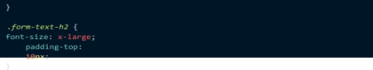

**Output:-**

**registration page:-**

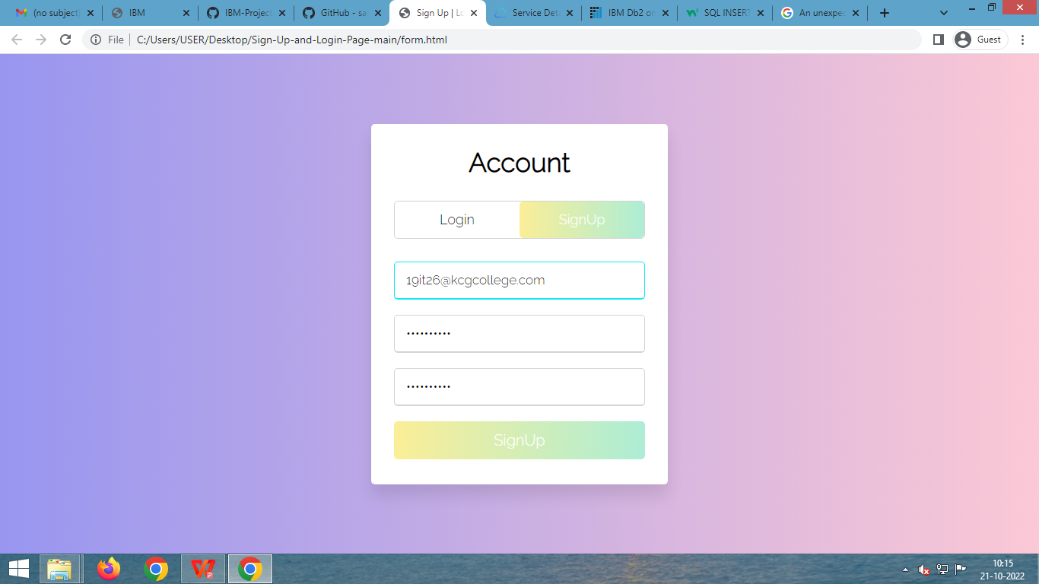

**Login Page:-**

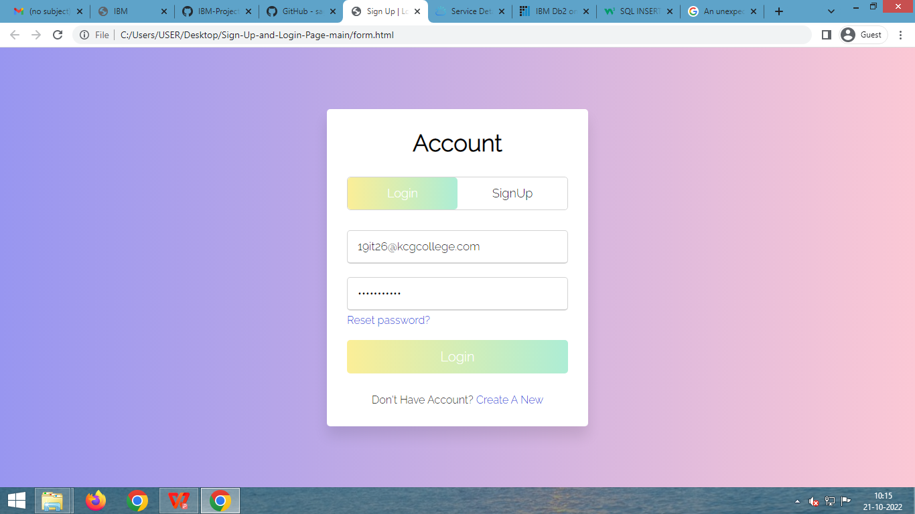

**Data Base Table :-**



